**Phys 135A College Physics I**

**Activity 8: Uniform Circular Motion and Universal Law of Gravitation**

Say you make the following curve with your car:

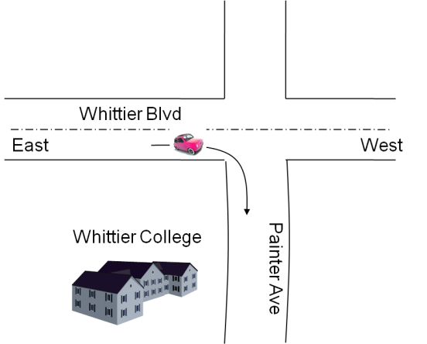

If your speed was 15 mph during the curving action, did you have any acceleration during that turn?

i-) YES (Explain why?)

ii-) NO (Explain why?)

Discuss your answer with your neighbor.

**Kinematics of Uniform Circular Motion**

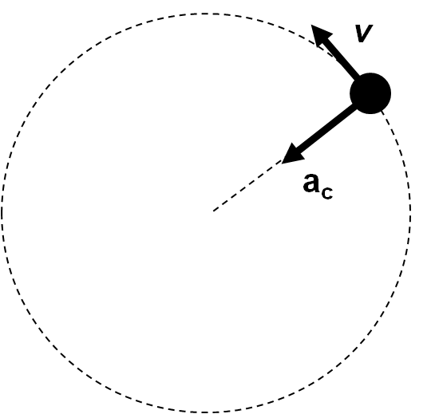

**Some definitions**:

$$frequency=f=\# of turns/ second$$

Standard unit is $1/sec$, which is called a hertz (Hz)! But, it can also be given as rpm, revs per minute.

$$Period=T=1/f (time to complete one revolution)$$

$$T=\frac{2πr}{v}$$

$$v=\frac{2πr}{T} (linear speed)$$

$$ω=2πf=2π/T (angular frequency)$$

$$a_{c}=\frac{v^{2}}{r} (centripetal acceleration)$$

$$v= ωr$$

$$a_{c}=ω^{2}r$$

**Example**: (a) Compare the angular frequencies of A, B, and C.

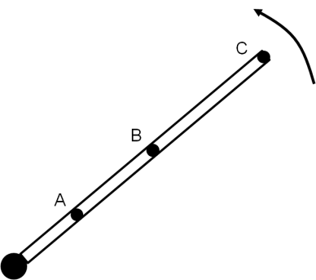

(b) Also compare their speeds and accelerations

**Example**: A 150 g ball is revolving at the end of a string in a uniform fashion horizontally. If the radius is 0.6 m, and the ball makes 2 revolutions per second, what would be its $a_{c}$?

**Example**: If the Moon completes one revolution around the Earth in 27.3 days, and its distance to the Earth is 384, 000 km, what is the Moon’s $a_{c}$?

**Example**: If the rotor of a vacuum cleaner has a radius r = 10 cm, and revolves with 600 rpm, what is its $a_{c}$?

Note that whenever there is a circular motion, then there is **always** an acceleration! From Newton’s second law, whenever there is acceleration, then there must be a net force causing that acceleration!

**Dynamics of Uniform Circular Motion**

Circular motion is described in terms of frequency of rotations per second!

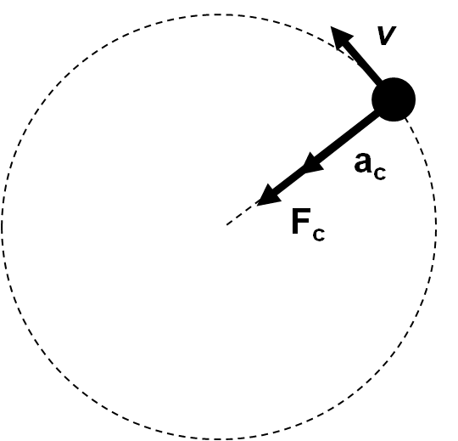

$$\sum{F=ma}$$

$$\sum{F_{c}=ma_{c}}$$

$$\sum{F_{c}=m\frac{v^{2}}{r}} (Master equation for UCM)$$

**Example**: A ball of mass m = 0.10 kg is tied to a string of radius r = 50 cm. Suppose you rotate the ball with your hand vertically in a unifrom circular motion.

(a) Determine the minimum speed the ball must have at the top of its arc so that it continues moving in a circle.

(b) What force would you have to apply to the string if the ball is to move with v = 2 m/s.

(c) Which way do you have to apply the force?

**Example**: Shown are three different instances of the Moon’s rotation around the Earth.

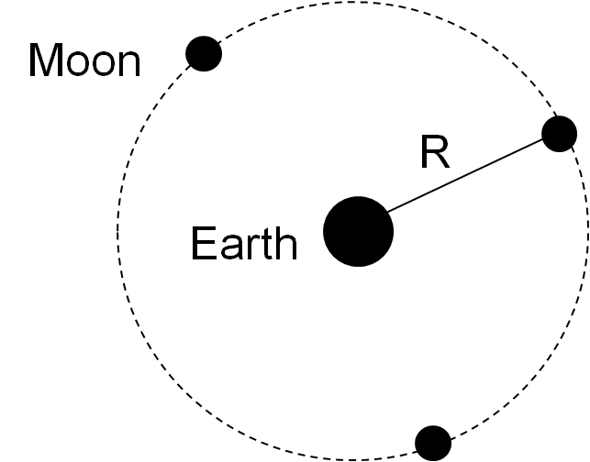

(a) Indicate the velocity vector of the Moon in each of these cases.

(b) What do you think is causing this change in the velocity vector?

**Corollary**: Any force that is center-directed will cause UCM, and will be said to be a centripetal force! In other words, centripetal force is just a name given to such forces! It is not a new type of force, say, like friction, or tension force! Everyday forces do produce the centripetal acceleration, and when they behave this way, we call them centripetal (center-seeking).

**Examples:**

1-) Spinning ball at the end of a cord:

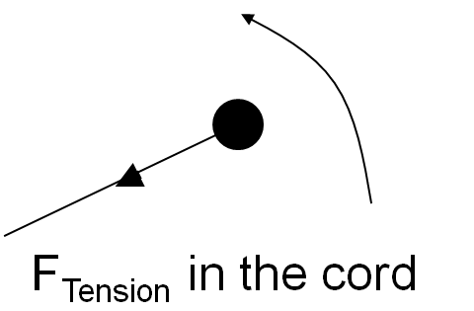

2-) A turning car on a road:

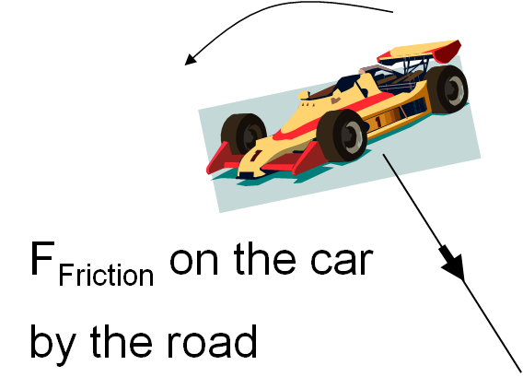

3-) Moon orbiting the Earth:

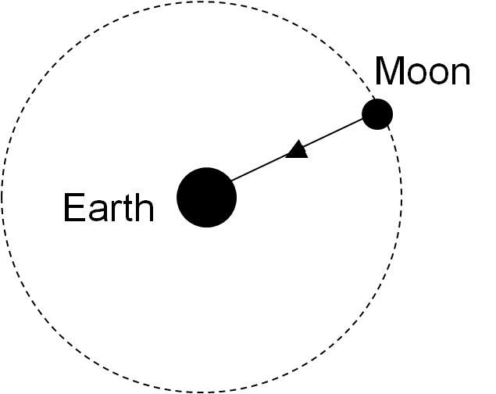

Please open the following link:

<http://phet.colorado.edu/simulations/sims.php?sim=Motion_in_2D>

Choose the circular motion option. Try moving the ball with the mouse observing what happens to the velocity and acceleration vectors.

**Newton’s Universal Law of Gravitation**

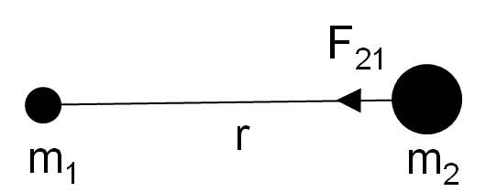

$F_{21}=G\frac{m_{1}m_{2}}{r^{2}}$,

where $G=6.67x{10}^{-11} Nm^{2}/{kg}^{2}$, and is called the gravitational constant.

**Example**: Calculate the force the Earth’s gravity exerts on you. $M_{Earth}=5.98x{10}^{24}kg$, $R_{Earth}=6380 km.$

**Example**: What is the force of gravity acting on a 2000 kg spacecraft when it orbits two Earth radii away from the Earth’s center.